**OBJECT ORIENTEND AND VISUAL PROGRAMMING**



**NABILA LATASYA (001202400042)**

**CLASS INFORMATION TECHNOLOGY 4**

**LIBRARY MANAGEMENT SYSTEM**

A.1 LOGIN PAGE

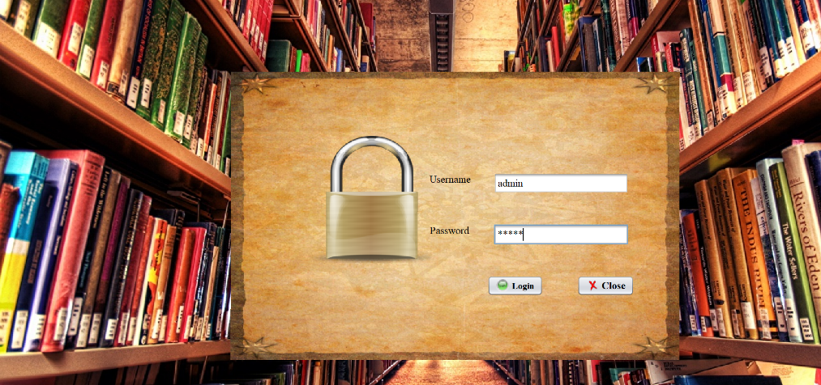

The login page is the first screen users see before accessing the library system. It requires users to enter their username and password to continue.

Main elements of this page include:

* A simple login form where users can input their credentials.
* Error notifications if incorrect login details are entered.
* Two main buttons: one to log in and another to close the application.

The background features a visual of library bookshelves, creating an academic and welcoming look. A lock icon placed at the center reinforces the idea of data security and restricted access.

**A.2 HOME PAGE**

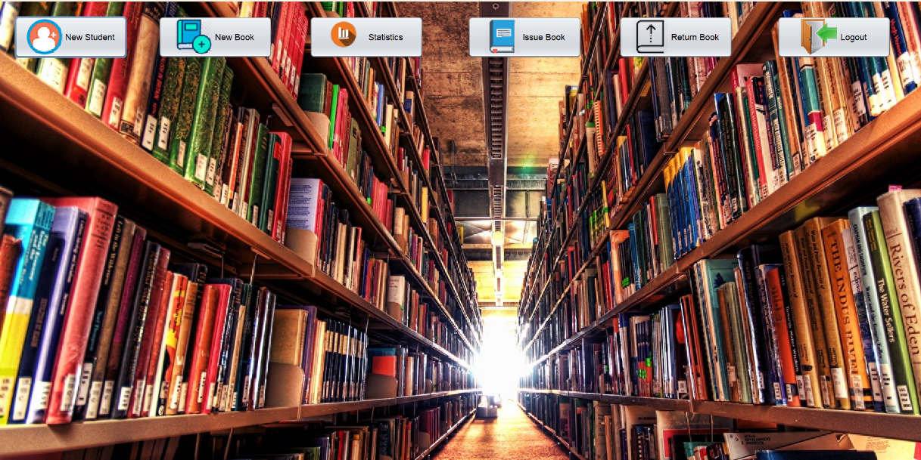

Once the admin logs in successfully, they are directed to the Main Menu. This interface is designed exclusively for administrators to manage the core operations of the library system.

Available features in this menu include:

* **New Student**: Registers a new student as a library member.
* **New Book**: Adds a new book entry to the library database.
* **Issue Book**: Records a book loan to a registered student.
* **Return Book**: Updates the system when a borrowed book is returned.
* **Logout**: Ends the current session and returns the admin to the login page.

The layout is organized with clearly labeled buttons and icons, allowing admins to perform tasks efficiently and manage library records with ease.

**A.3 NEW BOOK**

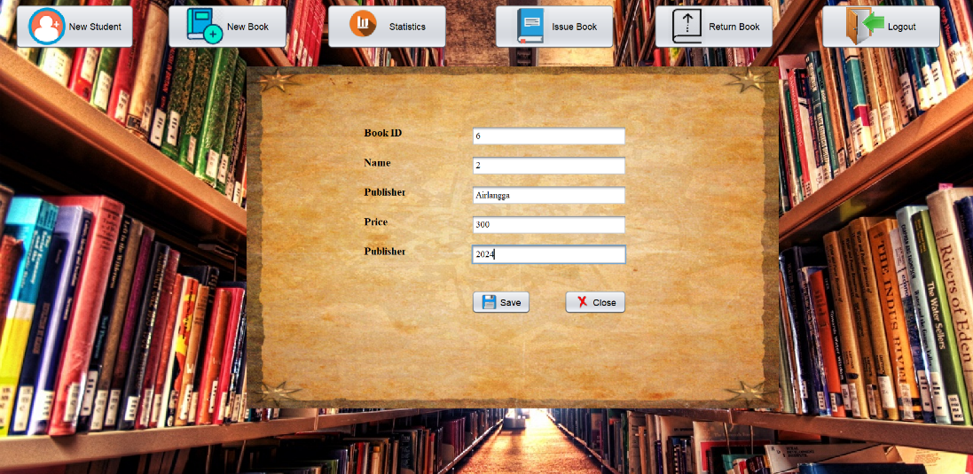

The **New Book** section allows administrators to add new titles to the library’s collection. This feature ensures that all book details are properly recorded in the system database.

Information required in this form includes:

* **Book ID**: A unique identifier automatically or manually assigned to each book.
* **Book Title**: The name of the book being added.
* **Publisher**: The name of the publishing company responsible for the book.
* **Price**: The cost or listed price of the book, used for inventory and reporting purposes.

This form helps maintain an organized and searchable digital catalog, enabling easier tracking and management of the library’s resources.

**A.4 NEW STUDENT**

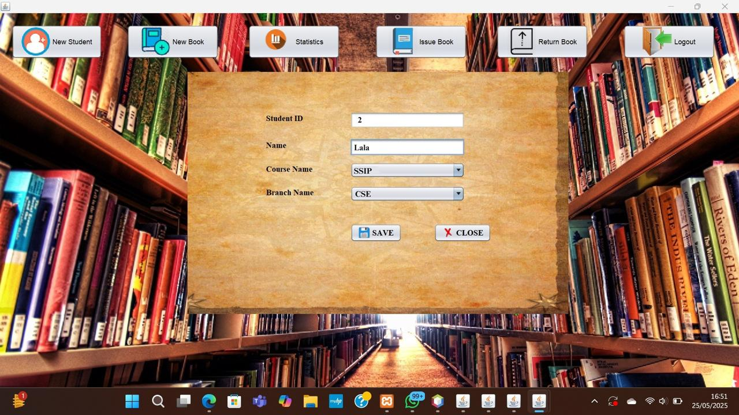

This is the "New Student" page of the library management system. It is used to add a new student to the system's database.

Page Overview:

* The page contains a simple form where the librarian or admin can input student information.
* The fields included in the form are:
  + Student ID: A unique identifier for the student (e.g., "2").
  + Name: The full name of the student (e.g., "Lala").
  + Course Name: A dropdown menu to select the student's course (e.g., "SSIP").
  + Branch Name: A dropdown menu to select the student's branch or department (e.g., "CSE").

Action Buttons:

* SAVE: Saves the entered student information into the system.
* CLOSE: Cancels the process and closes the form without saving.

This page helps manage student records efficiently by ensuring that each student is registered with accurate and organized data before they can borrow or return books.

**A.5 BORROW**

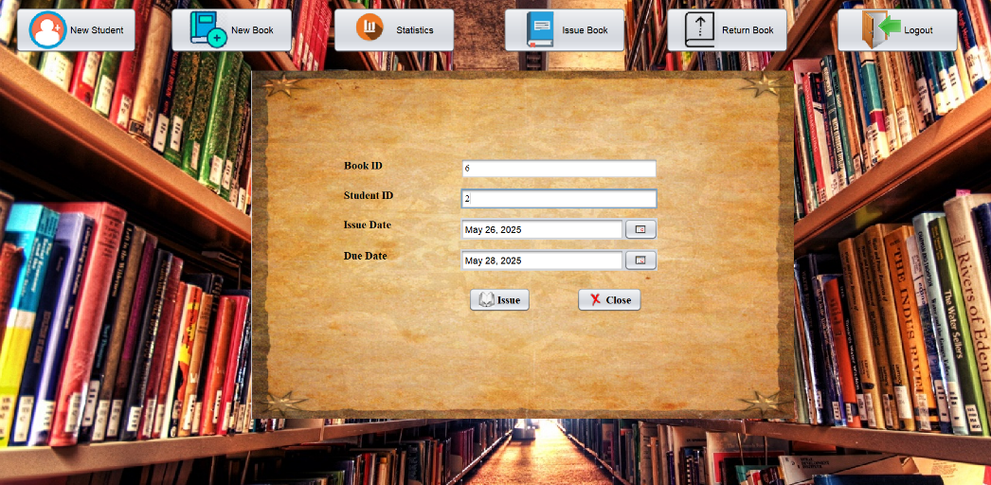

This page is used by the admin to enter student information when they want to borrow a book. The admin fills in details such as the student ID, Boo ID, Boorw Date and Due Date. along with the Book ID and book details. This ensures that the system has accurate records of both the student and the book being borrowed before processing the transaction.

**A.6 BOOK BORROWED**

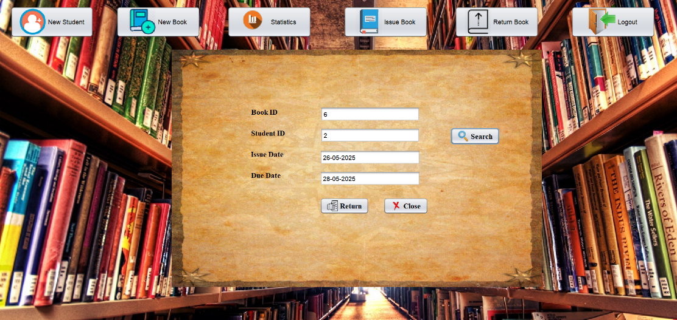

This page displays a list of books that are currently being borrowed. Each entry typically includes details such as the student’s name, book title, issue date, and due date. There are three main buttons on this page:

* **RETURN**: To process the return of a selected book.
* **SEARCH**: To find a specific borrowing record based on student or book information.
* **CLOSE**: To exit the page.

The interface helps the admin monitor ongoing borrowings and manage book returns efficiently.